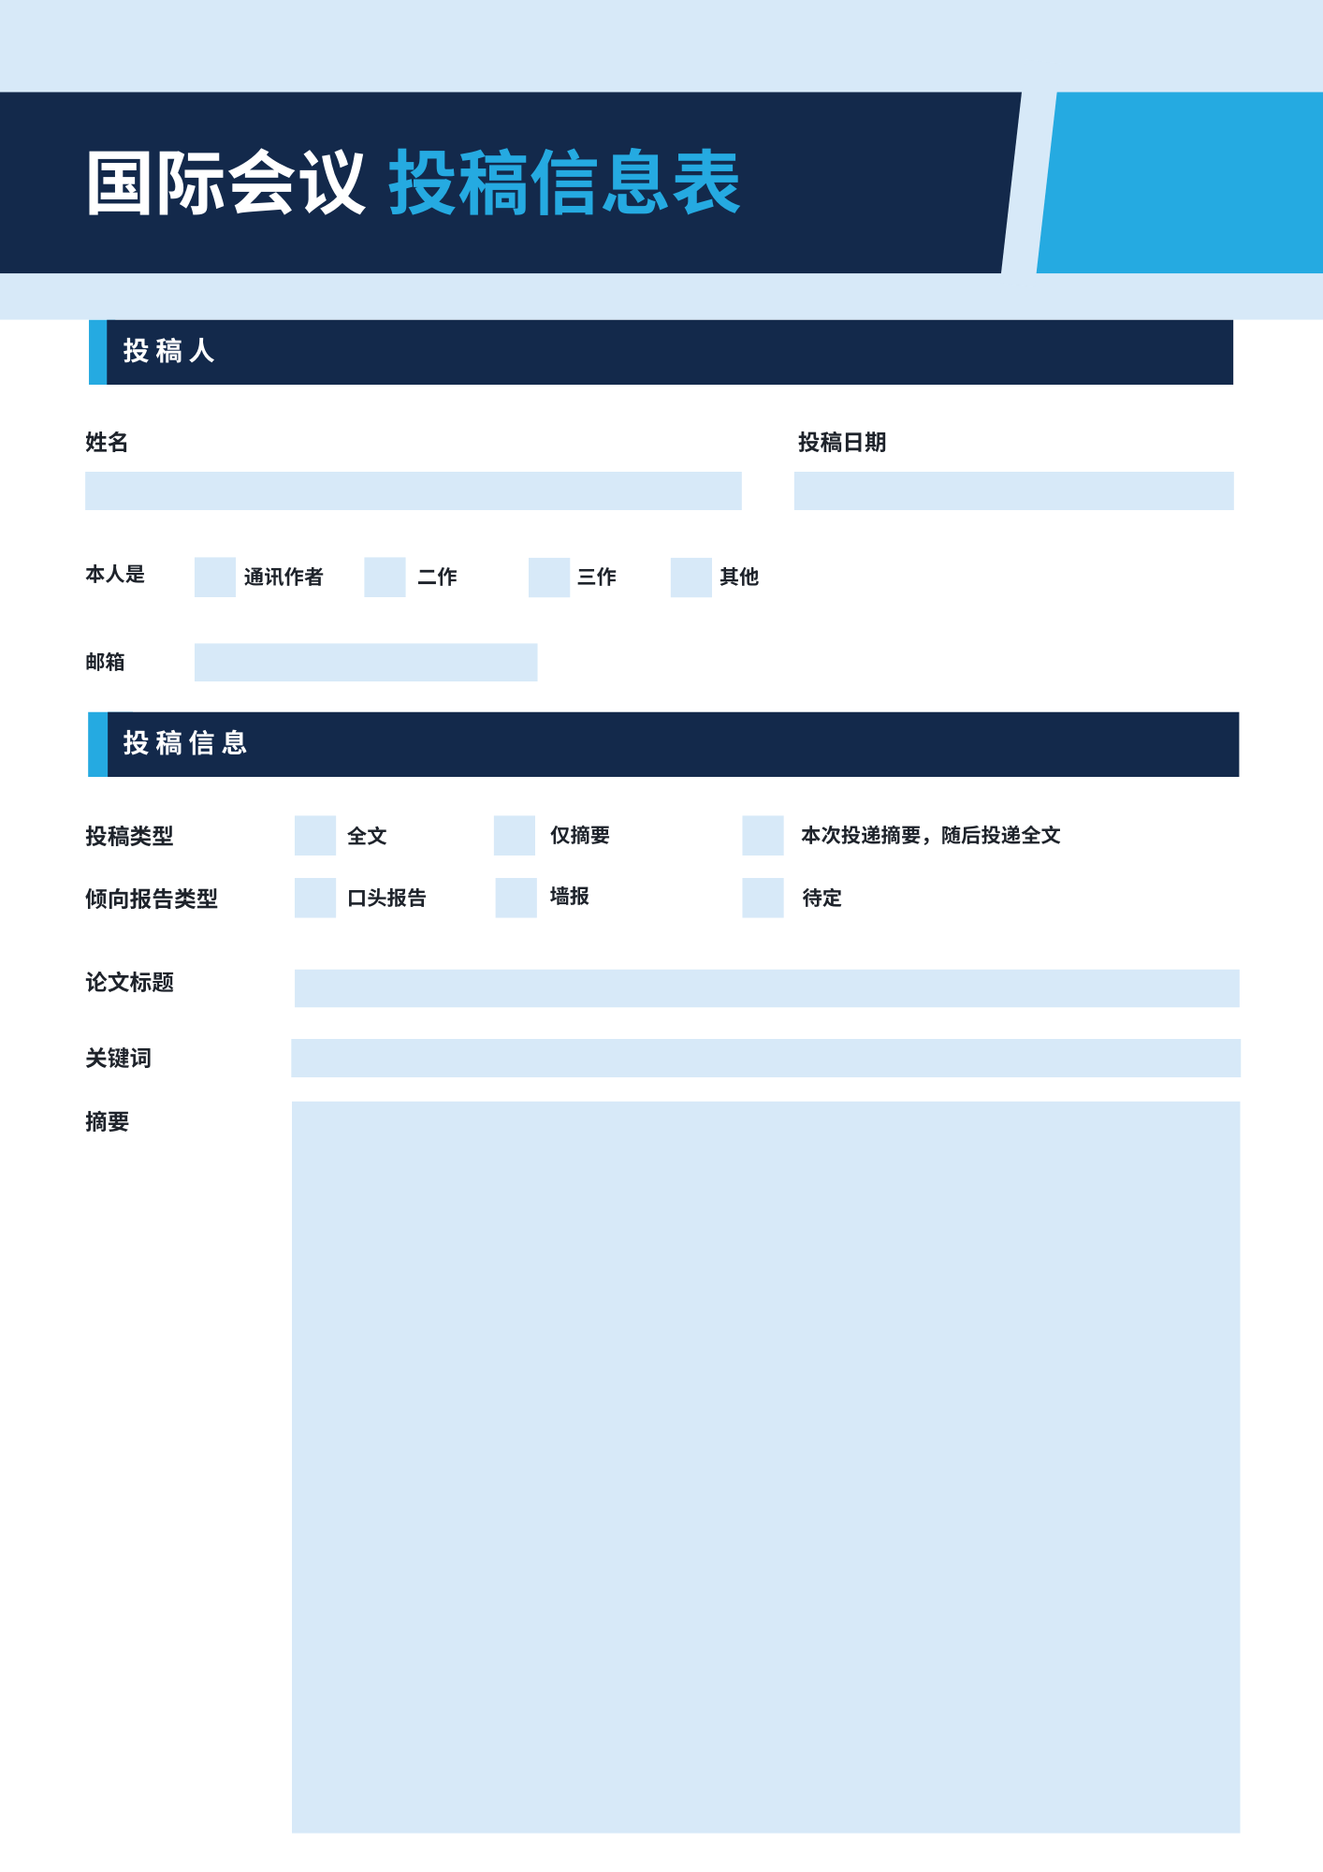



✔

✔

✔

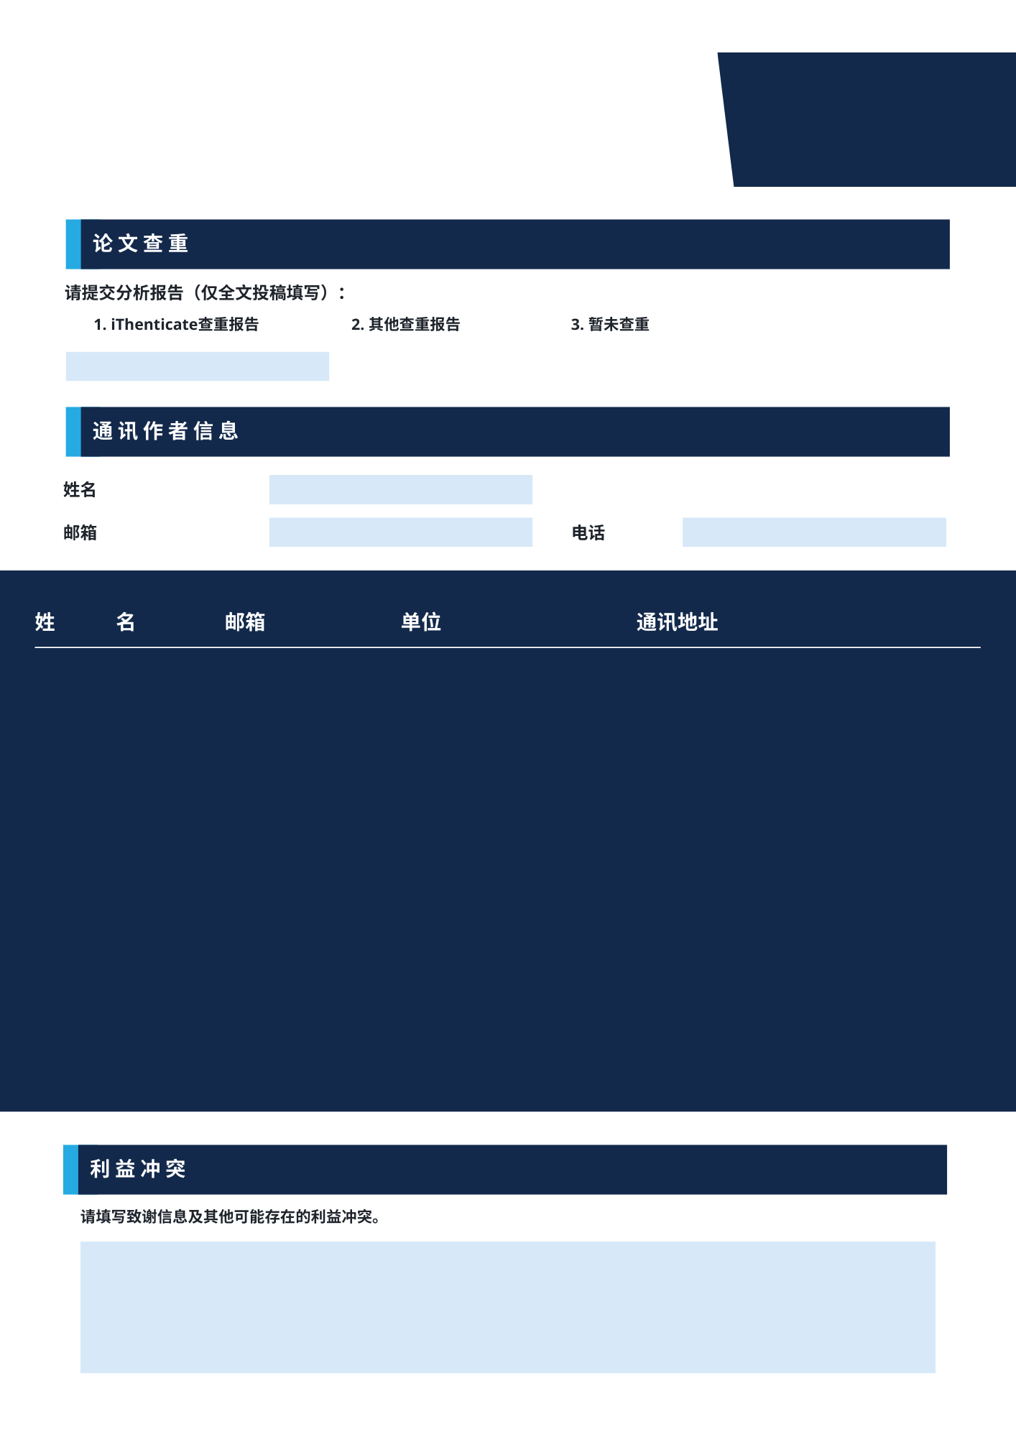



香港机器人与自动化协会

|  |  |  |  |  |
| --- | --- | --- | --- | --- |
| 作者1 |  |  |  |  |
| 作者2 |  |  |  |  |
| 作者3 |  |  |  |  |
| 作者4 |  |  |  |  |
| 作者5 |  |  |  |  |

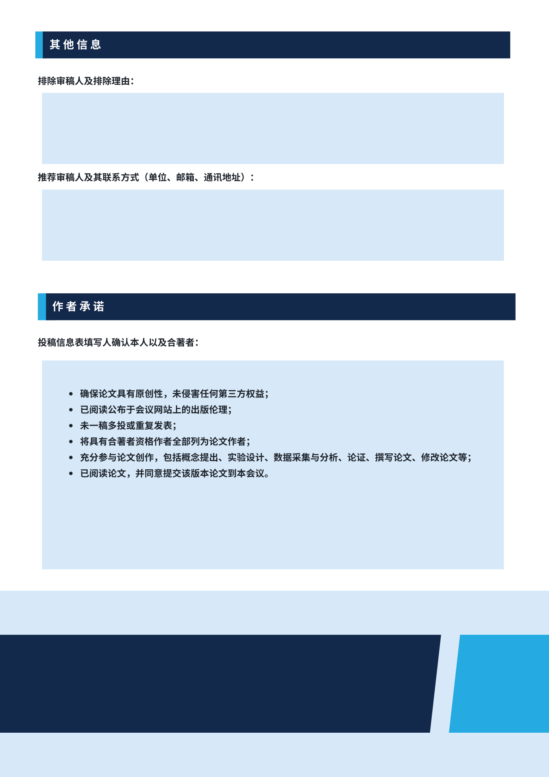



|  |  |  |
| --- | --- | --- |
| **作者** |  | **简介（150个单词以内）** |
|  |  |  |
|  |  |  |
|  |  |  |
|  |  |  |
|  |  |  |

**如有任何疑问，请发送电子邮件至**[**email@icpami.org**](mailto:email@icpami.org)**与我们联系。**